Amazon PPC Credit Card Workaround: Keep Earning 2X Points on Ad Spend in 2026

Amazon removed credit card payments for PPC in April 2026, quietly costing high-volume sellers $10K to $50K+ per year in travel rewards. Here’s the Bill.com workaround that keeps you earning 2X points on ad spend, fully tax-deductible, with clear net profit after fees.

Amazon stopped accepting credit card payments for PPC in April 2026. For sellers who built their ad strategy around the 30-day payment float and 2–4% card rewards, the change felt less like a policy update and more like a margin grab.
Amazon softened the blow with a $2,500 one-time ad credit and, after significant seller backlash, pushed the rollout to August 1, 2026. But the core issue remains: most sellers switched to ACH billing and walked away from the rewards game entirely.
They didn’t have to. There’s a workaround gaining traction in eCom seller communities that keeps you on credit card, still earning 2X points on Amazon ad spend, fully tax-deductible, with clear net profit after fees. It’s not a loophole. It’s a straightforward reroute using a tool most sellers already know.
Here’s how it works.

Amazon PPC Credit Card Removal: What Changed in April 2026

In early April 2026, Amazon began sending notices to a targeted segment of sellers announcing that advertising costs would be automatically deducted from sales proceeds. Credit cards would become backup payment methods only, used if proceeds couldn’t cover ad spend.
The pushback was immediate. A group within Million Dollar Sellers organized a one-day ad boycott, and a poll of over 100 founders found that a majority expected the combined impact of the advertising change and delayed payouts to reduce their available cash by more than $100,000 (Modern Retail, April 2026).
Amazon responded on April 15 by deferring the rollout to August 1, 2026, citing the need to give affected advertisers “more time to prepare” (CNBC, April 2026). The underlying mechanics of the change have not changed.
The effect for affected accounts:
- Ad costs deducted from proceeds before payout reaches your bank
- No more 30-day credit card float
- No more 2–4% rewards on Amazon ad spend
- $2,500 one-time ad credit as a transition softener

Amazon’s stated reasoning cited “cash flow management” for sellers. The more honest explanation is margin. Advertising is Amazon’s fastest-growing revenue segment, and eliminating interchange fees on seller ad spend (which run between 1.5% and 2.5% on billions in ad volume) contributes directly to their bottom line.
Steven Pope at My Amazon Guy described it as a “double whammy” for sellers: you lose the 30-day credit card float at the same time Amazon is already holding your sales proceeds for their own 30-day disbursement cycle. The result is roughly 60 days of working capital that quietly disappears. For sellers who had built that combined buffer into their cash flow planning, it’s a significant hit.

How Amazon’s Ad Payment Change Affects Seller Cash Flow and Rewards

For small advertisers, the $2,500 credit actually helps. For larger sellers, the math turns ugly fast.
Take a seller spending $500K per year on Amazon PPC. At an average 2% card reward value, that’s $10,000 in annual travel rewards, gone. At 4% (common with Amex Business cards on large charges), it’s $20,000. My Amazon Guy estimates the rewards loss alone can exceed $15,000 a year for high-volume sellers, before you even account for the lost cash flow window.
Stack that against the other recent hits to seller margin:
- Selling Partner API fees ($1,400 annual subscription, effective January 2026)
- Mandatory prepaid return labels (January 2026)
- Per-unit billing for FBA removals (February 2026)
- Ongoing FBA fee hikes

Any single line item looks manageable. Combined, they’re a real squeeze on already-thin eCom margins. Which is why finding a way to preserve the card rewards is worth the 30 minutes it takes to set up.
Worth noting: this pattern isn’t isolated to Amazon. Google Ads notified a segment of advertisers in June 2024 that credit and debit cards would no longer be accepted as primary payment methods. Meta did the same in February 2026. Amazon’s change is structurally similar to both (PPC Land, April 2026). The big ad platforms are all moving the same direction, which means finding stable workarounds matters more than ever.

The Bill.com Workaround: How to Keep Earning Credit Card Rewards on Amazon PPC
The workaround relies on two pieces:
- An invoicing platform that accepts credit card payments and pays vendors on your behalf (Bill.com is the most widely used)
- A catch-all rewards card with a strong multiplier on general business spend

The flow is straightforward. Amazon invoices you for ad spend (pay-by-invoice accounts). You route that invoice through the invoicing platform. You pay the platform with your credit card. The platform pays Amazon.
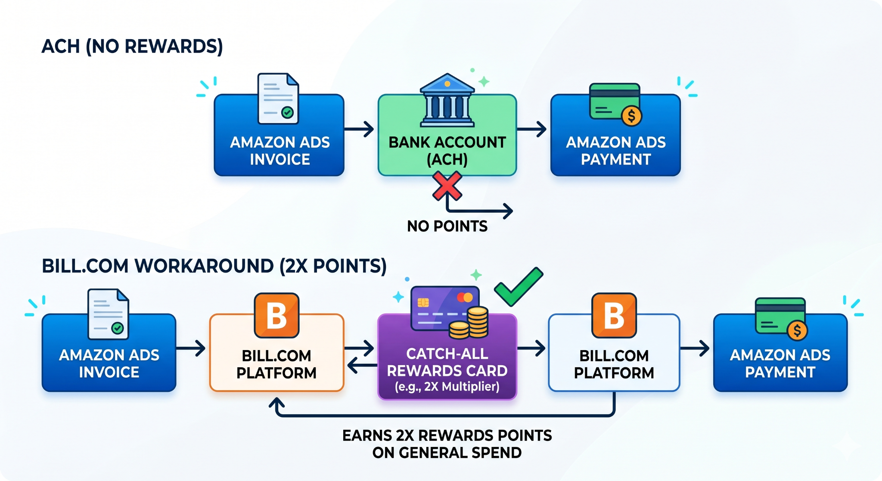
You keep earning points. Amazon still gets paid. The platform takes a 2.9% transaction fee, which is fully tax-deductible as a business expense.
This approach has been used in other industries for years. It works on Amazon ads as long as you’re on pay-by-invoice billing, which Amazon has confirmed remains available (PPC Land, April 2026). Credit to Jon Spektor for breaking down this approach and the card math in public eCom community discussions.

How Pay-by-Invoice Billing Works on Amazon Ads
Pay-by-invoice is an Amazon Ads billing option where Amazon sends monthly invoices for ad spend rather than charging a card or deducting from proceeds in real time. Not every seller account qualifies — Amazon has tightened eligibility in recent years — but for accounts that do, it’s the gateway that makes this workaround possible. Confirm your eligibility inside Amazon Ads account settings before building the workflow below.

The Effective Fee After Taxes
Bill.com charges 2.9% on card payments. That sounds steep, but since it’s a business expense, you deduct it. In the 37% federal tax bracket, the effective cost drops to roughly 1.8%. In states with income tax, it drops further.
For the workaround to be profitable, your card rewards value needs to exceed 1.8%. Most quality business credit cards clear that bar easily.

Best Credit Cards for Amazon PPC Payments Through Bill.com
Here’s the catch: Bill.com payments don’t code as “advertising” to your card issuer. So cards with high multipliers tied to specific categories (like Amex Gold 4X on ads, or Chase Sapphire’s bonus categories) won’t give you those multipliers on Bill.com charges.
You need a catch-all card with strong flat rewards or a high multiplier on general large-ticket business spend. Three cards stand out.

Card | Rewards | Annual Fee | Best For
Amex Business Platinum | 2X points on charges over $5K | $895 | Sellers with $100K+ annual ad spend and travel goals
Chase Ink Unlimited | Flat 1.5X points on everything | $0 | Smaller sellers or Hyatt/Chase ecosystem users
Chase Ink Business Premier | 2.5% cash back on $5K+ charges | $195 | Sellers who prefer cash over travel

Amex Business Platinum: Best for High-Volume Amazon Sellers
The standout for most sellers running significant PPC budgets. At 2X points on $5K+ charges, valued at roughly 2 cents per point in travel, that’s an effective 4% return on Amazon ad spend. Against a 1.8% effective fee, you’re netting 2.2% or better. It also comes with a 150K–300K signup bonus after $20K in spend, which most Amazon sellers hit quickly, plus Dell and Adobe credits worth $400+ in annual practical value.

Chase Ink Unlimited: Best for Fee-Averse Sellers
Makes sense if you’re fee-averse or use Chase points in the Hyatt ecosystem where redemption values stay strong. Flat 1.5X on everything still clears the 1.8% effective fee threshold when you account for state income tax deductions, particularly in high-tax states.

Chase Ink Business Premier: Best for Cash Back
The cash-back play. After tax-adjusted fees, you net around 0.7% back in states with no income tax, higher elsewhere. Simple, predictable, no points program management required.

The Math at $500K Annual Amazon Ad Spend
Here’s what the Amex Business Platinum workaround looks like on $500K in annual PPC spend:

Item | Amount
Ad spend | $500,000
Bill.com fee (2.9%) | $14,500
Tax savings on fee (37% bracket) | −$5,365
Net fee cost | $9,135
Points earned at 2X | 1,000,000
Travel value (2 cents per point) | $20,000
Less: Amex annual fee (tax-adjusted) | −$564
Net profit | $10,301

That’s roughly $10,000 in clear, tax-adjusted profit per year for flipping a billing flow. Plus you keep the 30-day cash flow buffer that ACH billing eliminates. Scale up to $1M in annual PPC and the math roughly doubles.

How to Maximize Amex Points from Amazon Ad Spend: Transfer Partners Explained
The $20,000 travel value used in the calculation above assumes 2 cents per point — what you’d get booking through the Amex portal or transferring to Delta SkyMiles. Fine, but it leaves significant value on the table.
The real upside with Amex Membership Rewards comes from transferring to partner airlines for premium cabin awards. A roundtrip business class ticket from the US to Europe typically runs $5,000–$7,000 in cash. Through transfer partners like Air France/KLM Flying Blue, Virgin Atlantic Flying Club, or Iberia Plus, the same flight can book for around 80,000 points roundtrip depending on route and date.

Scenario | Value
Business class roundtrips (US–Europe) at 80K pts | ~12.5 trips
Cash equivalent at $5,000 per ticket | $62,500
Cash equivalent at $7,000 per ticket | $87,500
Effective points value (conservative) | 6–8 cents per point

Using a conservative 6 cents per point:

Item | Amount
Gross travel value (1M points at 6 cents) | $60,000
Less: Net fee cost | −$9,135
Less: Amex annual fee (tax-adjusted) | −$564
Net value with partner transfers | $50,301

At 8 cents per point (achievable with sweet-spot redemptions), net value approaches $70,000 per year. Transfer partner sweet spots shift over time — airlines devalue programs and availability varies — but the 3X–4X multiplier over base redemption value has held steady across multiple programs.

How to Set Up Bill.com for Amazon PPC Payments (Step-by-Step)
Before you start, work through these steps in order:
- Confirm your Amazon account supports pay-by-invoice billing. Not all accounts do. Amazon has confirmed pay-by-invoice remains available, but eligibility varies by account.
- Set up a Bill.com account (or equivalent invoicing platform that accepts card payments and can pay vendors on your behalf).
- Add your chosen catch-all rewards card as the payment method on Bill.com.
- Route Amazon ad invoices through Bill.com. Most sellers set up monthly invoicing with Amazon Ads, then pay those invoices through Bill.com.
- Track everything for tax purposes. Your CPA will need clean records of the Bill.com fees as deductible business expenses.

Bill.com Amazon Ads Workaround: Eligibility, Risks, and Tax Considerations
A few honest caveats before you implement:
- Eligibility varies: Not every seller account qualifies for pay-by-invoice billing. Amazon has tightened eligibility in recent years, particularly for smaller or newer sellers.
- Tax bracket matters: The 37% bracket example is aggressive. At lower brackets, the effective fee is higher and the margin tightens.
- State tax matters: Sellers in no-income-tax states (Florida, Texas, Washington) get a smaller deduction benefit. Sellers in California or New York get a larger one.
- Keep clean records: This is a legitimate use of invoicing platforms, not a hack. But keep clean records and confirm with your CPA before implementing at scale.
- Watch fee changes: Payment processors adjust fees. If Bill.com raises the card processing fee above ~3.2%, the math gets tight.

Reducing Amazon Seller Operating Costs: Offshore Hiring as a Margin Lever
Most sellers squeezing margin at this level are already optimizing ad spend, negotiating vendor costs, and scrutinizing every fee line. The biggest remaining lever is almost always team structure.
An Amazon PPC Specialist in the US costs $65K–$90K per year. The same role hired offshore through a proper employment model — full Philippine employee with benefits, not a contractor — costs $18K–$28K per year, with comparable skill and significantly better retention. Multiply that across catalog management, bookkeeping, logistics, and EA roles, and the savings dwarf any PPC points strategy.

How HireAllStars Places Offshore Amazon PPC Specialists
That’s what we do at HireAllStars. We’ve placed 450+ eCom hires for Amazon sellers, agencies, and DTC brands. Our placements are full Philippine employees with benefits — not contractors — which is why our retention sits at 90%+ after year one (versus industry averages well under 70%).
If you’re squeezing margin on the ad side, team structure is the next lever worth looking at.

Next Steps
Book a 15-minute discovery call with our team to talk through your team structure and see where lean offshore talent fits into your P&L. Or explore the roles we place and the savings on our website.

→ Book a Discovery Call: calendly.com/hireallstars/discovery-call
→ See Roles & Savings: hireallstars.com/how-much-can-you-save

Disclaimer: This article is for informational purposes only and does not constitute tax, legal, or financial advice. Consult your CPA before implementing any billing changes. Card rewards values are estimates and vary by redemption method. HireAllStars is not affiliated with Bill.com, American Express, Chase, or any of the publications cited.

